**Table of Contents**

Detailed Description …………………………………………………………………. p.1

Version History …………………………………………………………………. p.2

Typography and Colour …………………………………………………………………. P.3

Wireframes …………………………………………………………………. P.4

Screen Captures …………………………………………………………………. P.5

**Detailed Description**

ASP.NET Web Forms Application that will track four different games or contests for each calendar week. Our Main Game Tracking Page will display the weekly statistics of each game. Each game will track two teams and our web application will record which team won the game. Our Web App will also measure how many points were scored and how many points were allowed (or lost) for each team and how many spectators watched each game. Appropriate User Input Validation throughout our web application. The weekly results is recorded in a database using appropriate tables and relations.

**Version History**

Version 0.0.1 – Alpha

Version 0.0.2 – Added Header Comments, and pages for Login, Register, Tracking, and ContactForm.Master

Version 0.0.3 – Added Wireframes to wireframes section

**Typography and Colour**



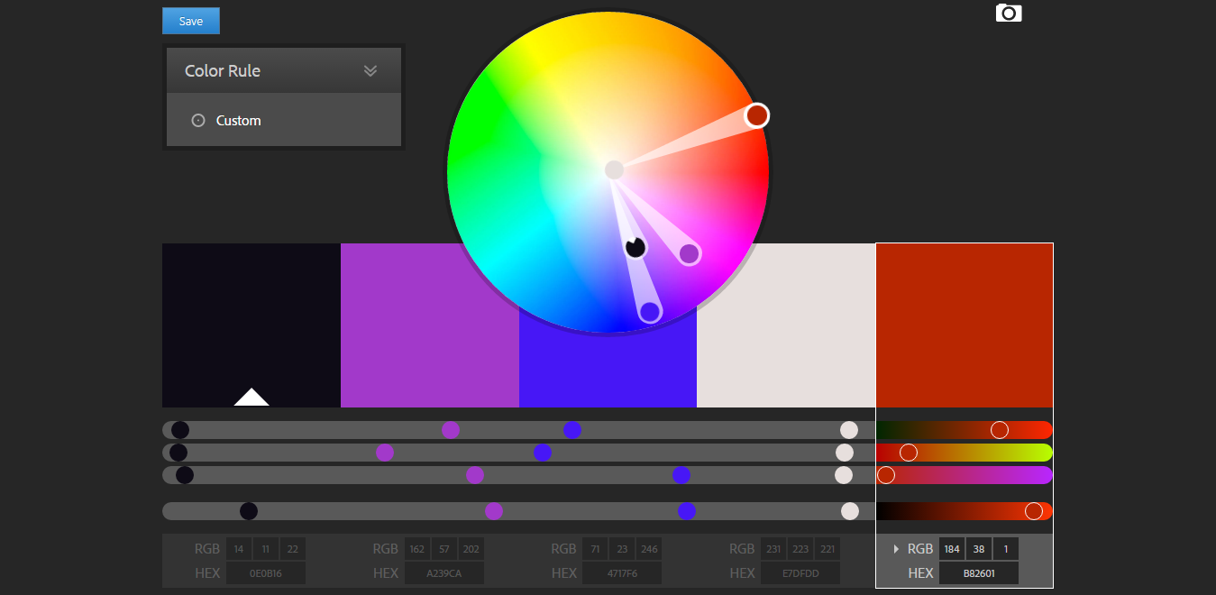

**Wireframes**

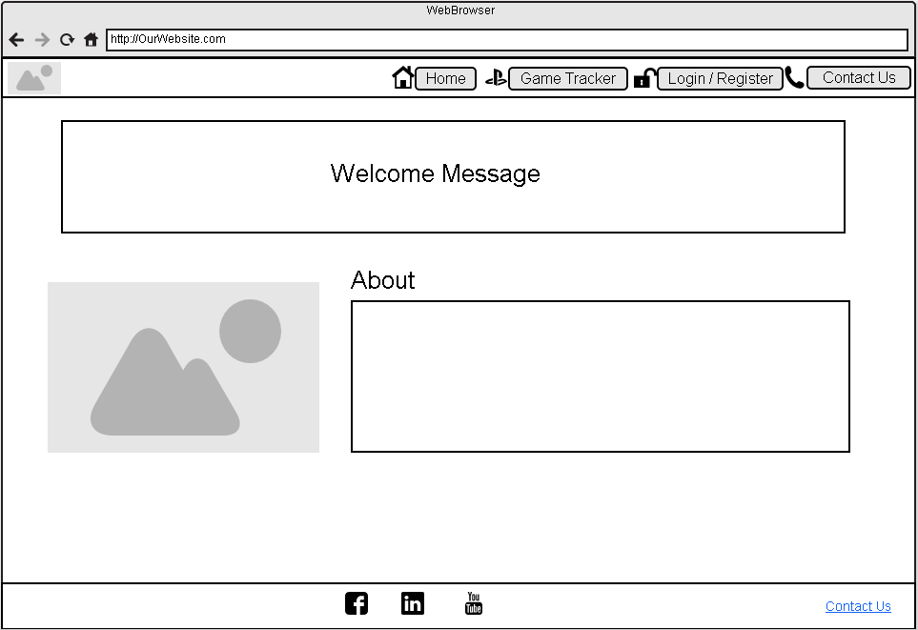

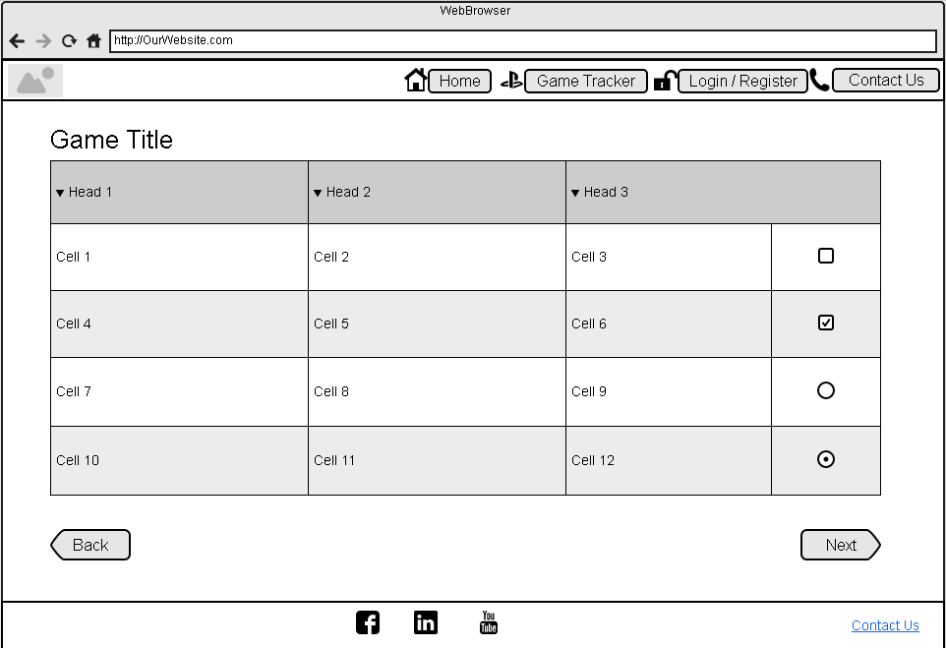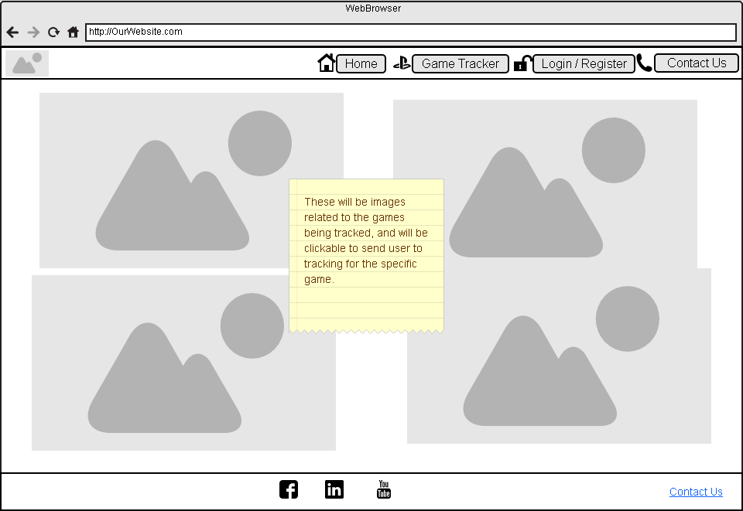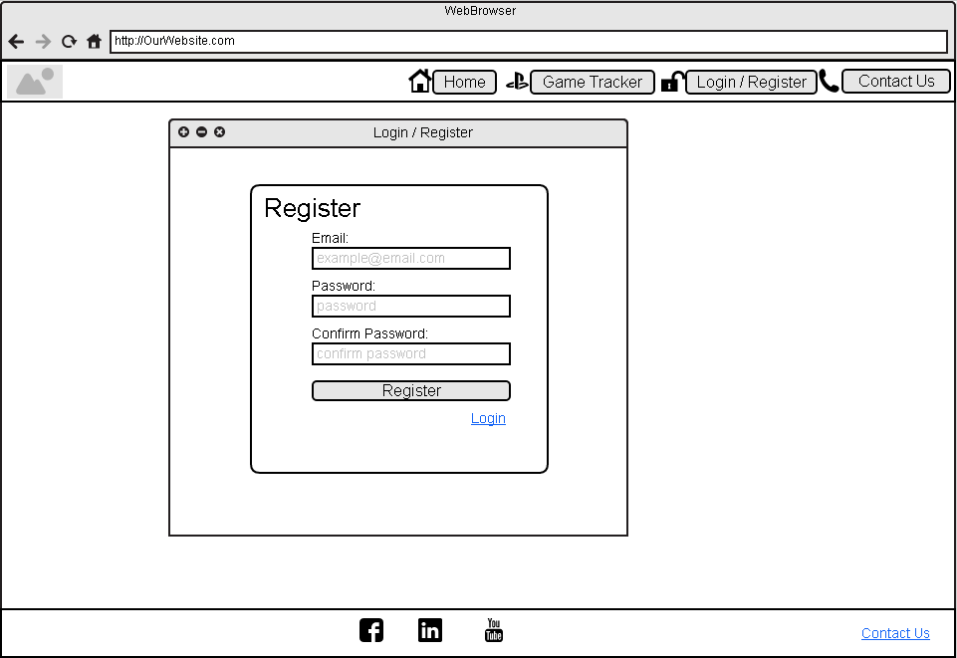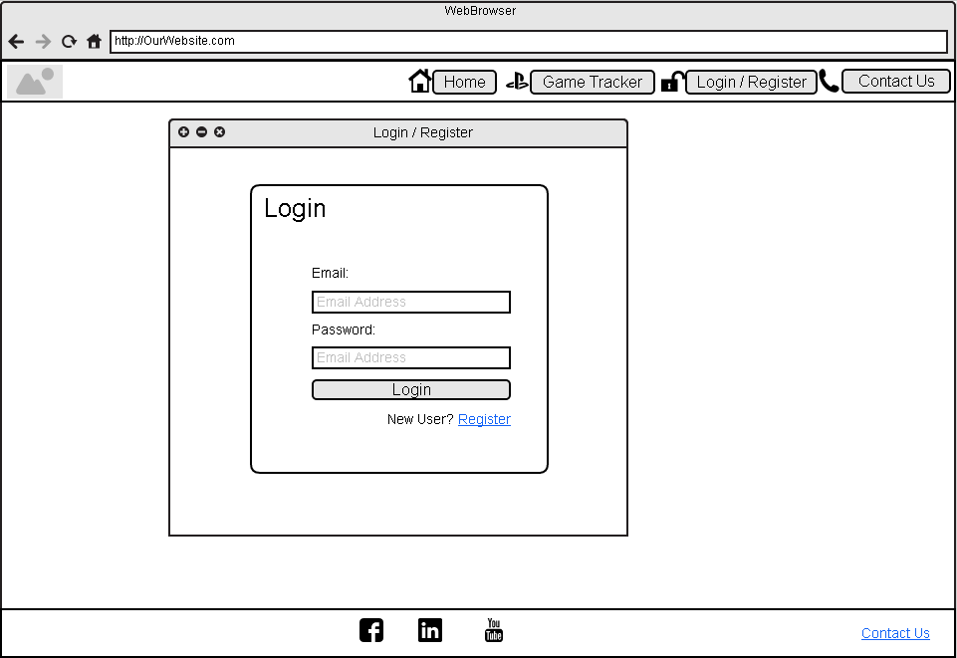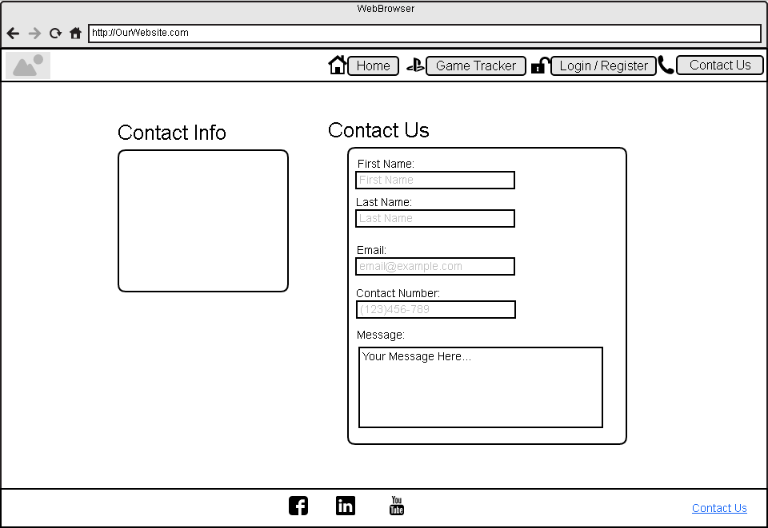

**Screen Captures**